DM2

Final project Report

Rec Online

final project  
report

900 fifth street

nanaimo, bc, v9r 5s5

rec online

# introduction

DM2 was approached to develop an online user friendly interface for Nanaimo sports and recreation. This report details the development process, from start to the high-fidelity prototype. Supporting artefacts, generated throughout the process, are attached in the annexes.

# The problem

Members of the local community have difficulty finding information about local sports and recreational activities. Often, pieces of this information are available through a variety of mediums and if the member misses a piece of information, they miss important deadlines for these activities.

As well, many organizations in the area are looking for ways to improve participation in their events. It is this participation, and the funds it generates, that permits the organizations to run these events.

What is needed is a way to bring together the organizers and the participants in an effective and efficient manner.

DM2 presented a Project Proposal to the Project Sponsor, Sarah Carruthers, along with an example consent form and a list of survey questions (see Annex A).

# The process

In an effort to gain more knowledge about the potential users, the tasks, and the requirements, the researchers at DM2 produced and conducted a survey (see Annex A) of volunteers in the local area. These results were studied and interpreted to produce six general classes of users. These six classes were used to generate six User Personas (see Annex B) to give the design team a better realization of the potential users.

The team then set out to design individual task scenarios to capture the various tasks that the system would have to be able to respond to. It was identified, at this time, that the organizer of the event would also be a user of the system and that their tasks would be different from other users. It was decided that DM2 would only provide the GUI for the Participant users and not the Organizer users.

Two task scenarios were identified and developed that would involve most of what the Participant user would be expected to use of the system (see Annex C). From these task scenarios, Use Cases were developed and a conceptual prototype was designed (see Annex D).

At this stage in the development process, and at the behest of Dr. Carruthers, DM2 elected to employ parallel prototype development. Three low-fidelity prototypes were developed in parallel. After careful consideration and feedback from the Project Sponsor, a single prototype was selected that encompassed all the elements of the three (See Annex E).

Through the reiterative process, the employment of the Balsamiq prototyping tool, and three parallel cognitive walk-throughs (see Annex F), a mid-fidelity prototype was developed.

This prototype was then subject to Heuristic Evaluation by an anonymous group, and their feedback was incorporated into the prototype prior to user testing.

A plan for user testing was then developed, along with a sample consent form, and a proposal with both attached, was sent to the Project Sponsor (see Annex G). After slight revision, this plan was implemented and user testing was conducted.

# The product

Change the information on the cover page to reflect your report. For the body of the report, use styles such as headings 1 through 5, body text, block quotations, list bullets, and list numbers from the **Style** list on the **Formatting** toolbar.

This report template is complete with styles for a Table of Contents and an Index. On the **Insert** menu, point to **Reference**, and then click **Index and Tables**. Click the tab you want, and then choose the options you want.

The index field collects index entries specified by XE. To insert an index entry field, select the text to be indexed. On the **Insert** menu, point to **Reference**, and then click **Index and Tables**. Click the **Index** tab, and then click **Mark Entry**.

Tip: You can also open the **Mark Index Entry** dialog box more quickly by pressing ALT+SHIFT+X. The dialog box stays open so that you can mark index entries. For more information, see Help.

In addition to producing reports, this template can be used to create proposals and workbooks. To change the text or graphics:

1. Select any paragraph and start typing.
2. To save time in the future, you can save the front cover of this report with your company name and address. For step-by-step instructions on how to preserve your changes with the template, see the following section.

# how to Modify this report

To create your own version of this template:

1. Insert your company name, address and other information in place of the text on the cover page.
2. On the File menu, click Save As. In the Save as type list, click Document Template.

# How to Create a Report

To create a report from your newly saved template, on the **File** menu, click **New** to reopen the template as a document. (Your company information should appear in place.) For the body of your report, use styles, such as Headings 1-5, Body Text, Block Quotation, and List Number, from the **Style** list on the **Formatting** toolbar.

## How to Create Bullets and Numbered Lists

1. To create a bulleted list like this, select one or more paragraphs and click the **List Bullet** style in the **Style** list on the **Formatting** toolbar. To create a numbered list like the numbered paragraphs above, select one or more paragraphs and click the **List Number** style in the **Style** list.

This style—the **Block Quotation**—can be used for quotes, notes, or paragraphs of special interest. To use the **Block Quotation** style, select any paragraph and then click **Block Quotation** in the **Style** list.

## How to Create a Footnote

To create a footnote, on the **Insert** menu, point to **Reference**, click **Footnote**, and then click **Insert**.

## How to Force a Page Break

In general, the best way to force a page break is to first insert a blank paragraph, and then click **Break** on the **Insert** menu. In the **Break** dialog box, click **Page Break**, and then click **OK**.

# more template tips

Two ways to view the various style names for template text are:

1. On the Format menu, click Styles and Formatting. Click any paragraph. View the style name in the Formatting of selected text box in the Styles and Formatting task pane.
2. Click any paragraph. View the style name in the Style list on the Formatting toolbar.

## How to Create a Table

On the **Table** menu, point to **Insert**, and then click **Table**.

To modify an existing table, such as the table below, place your cursor in any cell and then use the **Table** menu to make the changes you want.

|  |  |  |
| --- | --- | --- |
| Competitor Ranking | Current Share | Share in 3 Yrs. |
| Largest competitor | 50% | 30% |
| Second largest competitor | 25% | 20% |
| Third largest competitor | 15% | 12% |

Table 1: Projected growth of competitors over 3 years.

## How to Edit Table Text

You can edit and format table text like regular text. Select it and then type to replace it. Use the **Format** menu to change the font and paragraph attributes.

## How to Change a Header or Footer

On the **View** menu, click **Header or Footer**. Then, you can change or delete the text in these sections just as you would any text. When you’re finished, click **Close**.

To delete a rule line in a header or footer, on the **Format** menu, click **Borders and Shading**, andthen click the **Page Border** tab. Under **Setting**, click **None**, and then click **OK**.

**Purpose and Justification**

This project will provide a link between event organizers and those wishing to participate in the organizers events.

**Project Requestor:**

Sarah Carruthers, Professor of Computer Sciences: 250-753-3245 [sarah.carruthers@viu.ca](mailto:sarah.carruthers@viu.ca)

**Statement of the Problem:**

Members of the local community have difficulty finding information about local sports and recreational activities in the local area. Often, pieces of this information are available through a variety of mediums and if the member misses a piece of information, they miss important deadlines for these activities.

**Project Deliverables and Beneficiaries:**

At the conclusion of this project, DM2 hopes to have an On-line repository of sports and recreational activities. Community members can obtain information about these activities by selecting various search criteria to narrow their search.

Information about the events would be maintained by the organizing agency of the events and would include such information as age group, cost, location, duration, requirements, links to organization site, etc.

Members of the community will benefit from having all the information about local activities in an on-line centralized location that can provide readily avialable current and appropriate information on the activities they wish to enjoy.

**Strategic Context:**

Many organizations in the area are looking for ways to improve participation in their events. Many members of the community are looking for events to be involved in. This system will provide a vital link between the two.

**Time Factors:**

We would like to have a functional system completed by 17 November for presentation to the CSCI310 class.

**Users:**

This project will have two broad catagories of users, those of the organizers and those who wish to attend the events.

Within the Organizers, there will be sporting teams and events, recreational events, educational activites and events, and entertainment events.

Those attending the events will vary in many areas:

age group

physical capability

level of interest

gender

location

schedule

finincial disposition

etc.

**Special Provisions:**

None

**Project Assumptions and Constraints:**

Assumptions:

* Events will be maintained by organizers
* Community members will have access to a computer

Constraints:

* Nanaimo area events only
* Little to no cost to maintain

**Project Risks:**

There should be no risks involved with this project.

**Project Expenses:**

**Implementation Expenses:**

The costs of producing the questionnaires for interviews will be absorbed by DM2.

**Post-Implementation Expenses:**

Any costs of maintaining the system after implementation will be the responsibility of Vancouver Island University.

**Project Champion:**

Sarah Carruthers, Professor of Computer Sciences: 250-753-3245 [sarah.carruthers@viu.ca](mailto:sarah.carruthers@viu.ca)

**Primary Contant:**

Sarah Carruthers, Professor of Computer Sciences: 250-753-3245 [sarah.carruthers@viu.ca](mailto:sarah.carruthers@viu.ca)

**Major Stakeholders:**

David Burneau, VIU Student, 250-898-9885 aircrsq@gmail.com

Mohammad Al Atwi, VIU Student, 604 773 9722 alatmoha@hotmail.com

Mohammad Basheer, VIU Student, basheer.viu@gmail.com

**Consent Form For Participation in the Study Entitled:**

**“Designing and Evaluating an On-line Recreation Interface”**

***Statement of purpose:***

You are being invited to participate in a study entitled **Rec On-line** that is being conducted by **DM2 VIU Research.** This study is of no cost to the participant and you may decline at any time. You may contact **Basheer Mohammad** if you have further questions about this study, by email at [**basheer.viu@gmail.com**](mailto:basheer.viu@gmail.com).

The purpose of this research project is to design and evaluate a user interface of an on-line sports and recreation repository. You will be interviewed about your sports and recreational interest and requirements.

You will be asked to answer a series of questions about your which activities you are involved in, or would like more information about, and your ability to find information about said activities on-line. You will also be asked for some demographic information (age, occupation, etc.). Your participation should require about 15 minutes of your time. The results will be reported in a project report for CSCI 310 in the Department of Computing Science at the Vancouver Island University.

***Voluntary participation and the right to withdraw***

Your participation is completely voluntary and you can withdraw from the study at any time, without explanation. You have the right to refuse to answer any questions you do not wish to answer.

***Maintaining confidentiality and anonymity***

Any data collected in the study will remain confidential; interview results and questionnaires will be kept in a locked filing cabinet in a locked office. Only the principal and co-investigators (Mohammad Basheer, David Burneau, and Mohammad Al Atwi) will have access to the data. Your name will not be attached to any published results, and your anonymity will be protected by using code numbers to identify results obtained from individual subjects. You may request any data collected about you to be surrendered to you at any time.

***Disposal of interview material***

Your interview will be audio-taped (videotaped) and the tape will be erased immediately after your responses are coded in written form.

***Effect of participation/non-participation***

Whether you participate or choose not to participate will have no bearing on your grade/employment status/academic standing/job/services received.

**Signature of participant: Researcher:**

**Date:**

Interview Questions

1. What is your age group?

|  |  |  |  |  |
| --- | --- | --- | --- | --- |
| 15 – 25 Years | 25 – 35 years | 35 – 50 years | 50 – 65 years | Over 65 |
|  |  |  |  |  |

1. What is your gender?

|  |  |
| --- | --- |
| Male | Female |
|  |  |

1. What activities do you participate in?

* If you don't participate, do you like to chat with people with similar interests?

1. How often do you participate in these activities?
2. How much time do you spend on these activities?

|  |  |
| --- | --- |
| 2 – 3 hours a month |  |
| 2 – 3 hours a week |  |
| 2 – 3 hours a day |  |
| More than 3 hours a day |  |

1. What new activities would you be interested in participating?
2. How do you find out about these activities?
3. Do you have difficulty finding information about local activities?
4. If so, could you provide an example?

|  |  |  |  |
| --- | --- | --- | --- |
| Yes |  | No |  |

1. Do you have regular access to a computer?
2. Do you prefer;

|  |  |  |  |  |
| --- | --- | --- | --- | --- |
| Team Activities | Yes |  | No |  |
| Individual Activities | Yes |  | No |  |

|  |  |  |  |
| --- | --- | --- | --- |
| Yes |  | No |  |

1. Do you currently participate on a team activity?
2. Why do you participate in team activities?
3. At what level do you participate in activities?

|  |  |  |  |  |  |
| --- | --- | --- | --- | --- | --- |
| Professional | University | High School | Intermediate | Novice | Beginner |
|  |  |  |  |  |  |

1. Do you prefer to attend:

|  |  |  |
| --- | --- | --- |
| Unisex activities | Male activities | Female activities |
|  |  |  |

1. Do you participate in activities as a family?

* If so, which activities?

James Benjamin

|  |  |
| --- | --- |
| * James Benjamin * 17. * Grade 12 high school. * Wants to join RCMP. * Actively volunteers his time in community. * Uses Internet for multiple purposes and devices. * Has a fair amount of free time. * Very tech-savvy, thinks himself a computer tech. * Activities habits * Spends time studying, volunteering, and community activities with close friends. * Prefers structured sports and activities. * Prefers activities with similar age groups. | [https://encrypted-tbn2.gstatic.com/images?q=tbn:ANd9GcQNogpq4eq1bqWShZHPWPYbtXSgayPZNhxyv66xqfDNwray8PfARA](http://www.google.ca/imgres?imgurl=http://2.bp.blogspot.com/-7TUKP9LZbOM/T8XDQ8JTSdI/AAAAAAAACZw/f4tMXZvDU54/s320/cameron.jpg&imgrefurl=http://mikeb302000.blogspot.com/2012/05/accidental-shooting-of-younger-brother.html&h=291&w=320&tbnid=Eq3eNYowD3hI0M:&zoom=1&docid=flW6SMhWtXW4PM&ei=C_0eVL2vJ8m3iwLx_ID4CA&tbm=isch&ved=0CC4QMygmMCY4ZA&iact=rc&uact=3&dur=2775&page=5&start=127&ndsp=30) |

Maggie Lou

|  |  |
| --- | --- |
| * Maggie Lou. * 25. * New immigrant to Canada. * Moved recently to Nanaimo (a month ago). * Pharmacist. * Like to be active in her social life. * Doesn't ask for directions. * A lot of free time. * regular PC user for Email/Facebook/Chats * Activities habits * Enjoys participating in new activity. * Prefer Unisex activities. * Prefer team activities to make friends and learn new things. | [https://encrypted-tbn1.gstatic.com/images?q=tbn:ANd9GcSUa4MXi1RUwXFYpS6q1_eUXVOsqLHcSYoclFpyGQ0uGQvFoK5XnA](http://www.google.ca/url?sa=i&rct=j&q=&esrc=s&source=images&cd=&cad=rja&uact=8&docid=tebn4fwiPa2SiM&tbnid=jD2pHDSGiLOYFM:&ved=0CAcQjRw&url=http://commons.wikimedia.org/wiki/File:Chinese_Girl_1.jpg&ei=PQ4eVObqJMj2iwLTj4HIBQ&bvm=bv.75775273,d.cGE&psig=AFQjCNGd1flb97Fp2nT1WlyTpL14kHmlXg&ust=1411342237672750) |

Laila Hussain

|  |  |
| --- | --- |
| * Laila Hussain. * 30. * Mother of 3 kids. * Psychology student at VIU. * Like to be active in her social life. * Use internet to look for directions. * Limited time. * regular PC user for email/Facebook * Activities habits * Quality time with her family while doing activities. * Not afraid to try a new activity as long as it’s safe for her kids. * Prefer female and family activities. | [https://encrypted-tbn2.gstatic.com/images?q=tbn:ANd9GcRXtIgzKqsh8D45S8k57Uyv93P3WpzhINMnCQHbeXyWyvLQO0id](http://www.google.ca/url?sa=i&rct=j&q=&esrc=s&source=images&cd=&cad=rja&uact=8&docid=Ihrb3KYzYds_LM&tbnid=zjt-XgN8i8451M:&ved=0CAcQjRw&url=http://nabadnews.net/archives/category/arimaha-bulshada/page/51&ei=RBgdVLPyH6GyigKc6oCgCw&psig=AFQjCNERIIje_4JnTiP3Wu4I2ElqGdyFAg&ust=1411279260429793) |

Kelsea Nex

|  |  |
| --- | --- |
| * Kelsea Nex * 62 YOF, married, grandmother. * Quality Assurance Manager. * Well educated (BA). * Enjoys socializing. * Uses Internet for multiple purposes and devices. * Spends 2-3 hours per day enjoying activities. * Uses computers at work and at home, has three devices. * Activities habits * Spends time reading, quilting, and gardening with grandchildren. * Prefers less athletic activities. * Enjoys the social aspect of activities. | [https://encrypted-tbn0.gstatic.com/images?q=tbn:ANd9GcQShpmuO1EiFzE0bd6383qXxteg233czNSkndROHelcMhemwtnS](http://www.google.ca/imgres?imgurl=http://dailyplateofcrazy.com/wp-content/uploads/2013/09/Smiling-60-Year-Old-Woman.png&imgrefurl=http://dailyplateofcrazy.com/2013/09/15/would-you-brag-about-your-age/&h=405&w=447&tbnid=iiAYRsQmuCfvZM:&zoom=1&docid=xrRvd56kIb8X2M&ei=hP0eVMC8NorpigKxm4GwDw&tbm=isch&ved=0CIkBEDMoUTBR&iact=rc&uact=3&dur=7578&page=3&start=55&ndsp=30) |

Arlene Conway

|  |  |
| --- | --- |
| * Arlene Conway * 37 YOF, married, mother of two teenagers. * Community Support Worker. * Well educated (BSW). * Enjoys socializing. * Uses Internet for multiple purposes and devices. * Spends 2-3 hours per week enjoying activities. * Uses computers at work and at home, has three devices. * Activities habits * Fairly active with a variety of activities. * Prefers cheaper activities for her family. * Enjoys the social aspect of activities. | [https://encrypted-tbn3.gstatic.com/images?q=tbn:ANd9GcRzt0MxhagAHLN0CjUGH5bwedyn51WgHKS-6-J3E6n5fhHlQ8kOsQ](http://www.google.ca/imgres?imgurl=http://howtogetamannow.s3.amazonaws.com/wp-content/uploads/40-year-old-woman-e1339127824281-268x300.jpg&imgrefurl=http://howtogetamannow.com/2012/06/dating-advice-for-women-over-40-2/&h=300&w=268&tbnid=ZSCn1nwfv1oAsM:&zoom=1&docid=26HYRM5DimRGwM&ei=sQAfVIqLI6XHigLEvYBw&tbm=isch&ved=0CEoQMyhCMEI4ZA&iact=rc&uact=3&dur=2379&page=6&start=155&ndsp=27) |

Khalid al-dossari

|  |  |
| --- | --- |
| * Khalid al-dossari * 30 year-old male. * Student at VIU * Activities habits * Likes going to the gym a lot * Practices 5 times a week, 1 to 2 hours per day * Would like to try boxing * Easy going and social * Likes participation in teamwork * Professional athlete * Enjoys unisex activities |  |



James is looking for a team sport that he and his friends can participate in for an hour a day, three days a week, after school for no cost.

He pulls out his phone and searches for Ultimate Frisbee between 4:00 – 5:00 pm on Monday, Wednesday, and Friday.

He registers for the game at the Bevan Park Recreational Centre.

|  |  |
| --- | --- |
| User's Purpose | System responsibility |
| Enter Search Parameters | Show results |
| Select a result | Show information and registration information |
| Register | Send information to Organizer |

|  |  |
| --- | --- |
| User's Actions | System response |
| James enters one or more of the search parameters for the activity: team, time, date, | System displays search results |
| James selects a result | System displays detailed information about the organizer of selected result and registration information. |
| James chooses to register for result | Registration information is inserted into an email and a message box is displayed for any other comments to be inserted by James |
| James adds that two other friends want to partake in the activities as well | System confirms message sent. |
|  |  |
|  |  |



Katie is seeking for a group of people who want to join a Salsa dance classes. She wants to participate and practice 6 hours a week. She works Wednesdays to Saturdays. So she wants to find people who are will to practice Sunday to Tuesday.

She googled for a Salsa dance actives, but showed no result.

|  |  |
| --- | --- |
| User's Purpose | System responsibility |
| Enter Search Parameters | Show results |
| Select a result | Show information and registration information |
| Register | Send information to Organizer |

|  |  |
| --- | --- |
| User's Actions | System response |
| Katie looked up in the search “Google” for dance classes. | System displays search results |
| Katie looked for Salsa dance class specific. | System displays detailed information about the organizer of selected result and registration. And showed the nearest location. |
| Katie didn’t find a Salsa class in Nanaimo, so she might register in Dancing. | Registration information is inserted into an email is displayed for any other comments to be inserted by Katie |
| Katie picked 2 days a week. | System showed her Sunday and Tuesday. |
| Katie registered and paid for classes | System accepts the payment. |

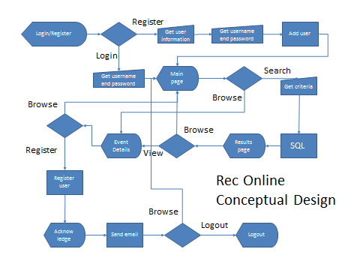

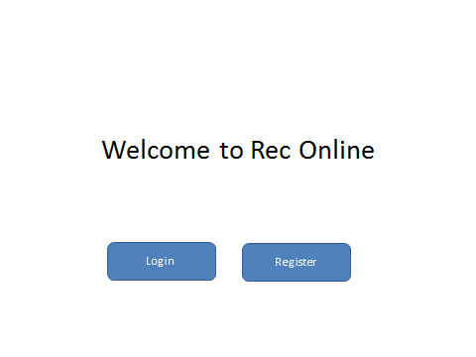

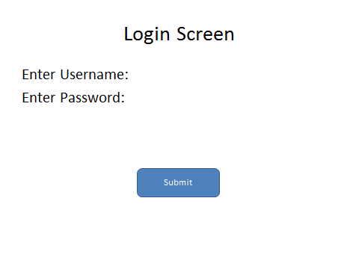

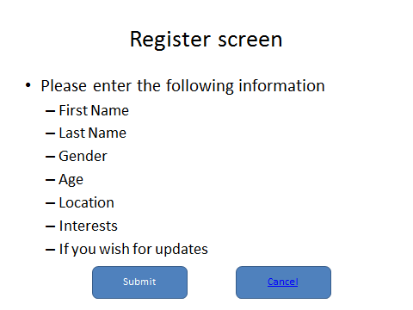

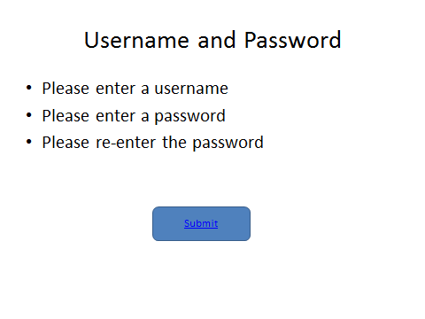

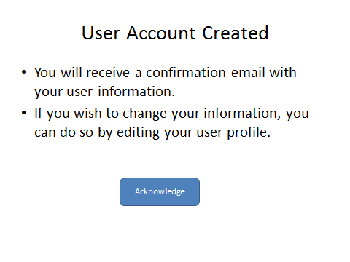

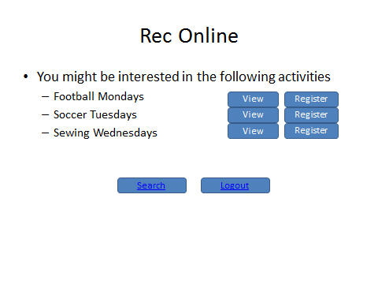

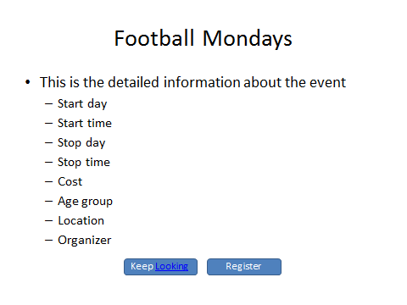

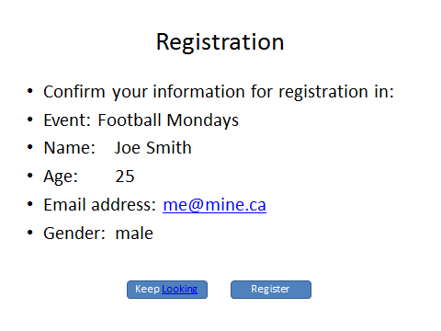

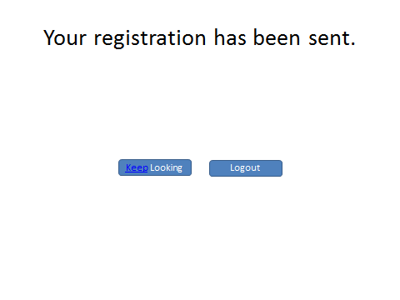

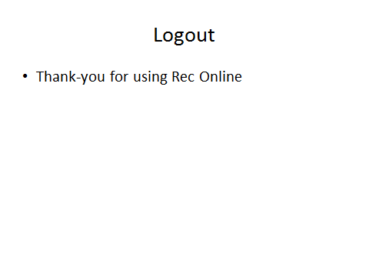

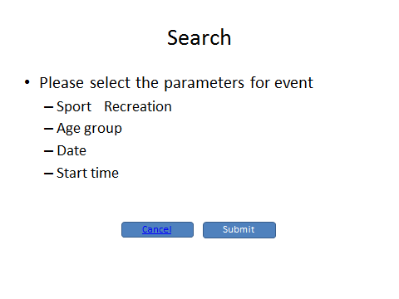

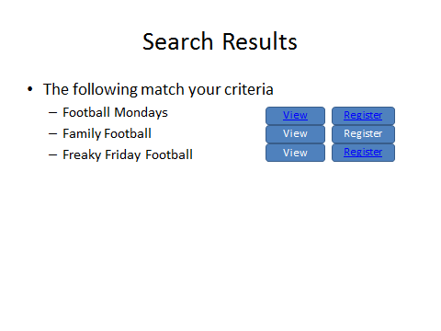

Cognitive Walk-through report

The following is a summation of the Cognitive Walk-through evaluation performed by David Burneau of DM2. It tries to answer the following four questions:

1. Will users be trying to produce whatever effect the action has?
2. Will users see the control (button, menu, or switch) for the action?
3. Once users find the control, will they recognize that it produces the effect they want?
4. After the action, will users understand the feedback they get so they can go on to the action with confidence?

Task 1 had the user login, search for an activity, and register in that activity, as outlined in Annex 1, while Task 2 had a new user register with the system, browse an activity, search for an activity, register for that activity, then logout, as outlined in Annex 2.

**Analysis of Task 1**

**Welcome Screen**

The user was able to navigate to the login screen with no hesitation, indicating that they had some reasonable idea of which button to press and what the expected outcome would be.

**Enter username and password**

The user hesitated on this screen, probably due to the lack of input area for their username and password, and because they weren’t a registered user; however, once informed, they were able to proceed with no difficulty, again indicating that the visibility, expected outcome, and feedback were acceptable.

1. The user reported that there was a need for input boxes for Username and password when logging in, and that the position of the prompts and boxes should be more centered in the screen.

Recommendation: Center the prompts and entry boxes to better meet visibility and consistency.

1. In addition to the above, the user also raised the concern about limits on username and password format.

Recommendation: Provide the user with a notice, when registering with the system, about the limits for usernames and passwords.

1. The user also inquired what would happen if the username or password was entered incorrectly.

Recommendation: Create “Invalid Username/Password” screen.

1. The user commented about the size and location of the buttons and how they did not comply with the principle of consistency.

Recommendation: Check location and size of all buttons for consistency.

**Select item to view**

The user selected to view the information about the Monday Football with slight hesitation, possibly due to multiple buttons with similar labels being in close proximity; however, the affordance and mapping of the buttons beside the events appears to have led the user to the desired goal.

The user reported the same issue of button alignment and size, as mentioned earlier.

View detailed information

1. In addition; the user was somewhat confused by the layout of the information about the event.

Recommendation: Adjust layout of event information.

**Search for activity**

The user was able to locate and activate the search button with little hesitation, and once on the search screen, was able to discern what information had to be entered.

As above, the user commented about the alignment and size of the buttons.

1. It was mentioned that the search parameters were lacking.

Recommendation: Display all search parameters

1. Check boxes instead of radio buttons would be more to the natural mapping of the user.

Recommendation: Change radio buttons to check-boxes

1. The user found that the slant created by the present order of the search parameters created a sense of leaning.

Recommendation: Switch the order of search parameters to prevent the illusion of leaning.

**Select to Register**

The user registered for the event with no difficulty, understanding what the registration button and expected outcome (registering for the event) would be.

1. The user reiterated the button alignment and size issue and mentioned about the order of information on the screen.

Recommendation: Reorder information on registration screen.

**Verify Information**

The user was able to acknowledge the screen quickly and was confident about the expected outcome.

Logout

The user was able to quickly understand the two buttons on the screen, and what the expected outcomes would be.

**Analysis of Task 2**

**Select Register**

The user quickly, and without difficulty, was able to locate and activate the Register button with a reasonable expectation of the outcome.

**Enter User Information**

Presented with the screen for user information, the user hesitated briefly, possibly due the task of completing the registration information.

The following were mentioned in the comments

1. Drop-down lists for gender
2. Which format to enter birthdate
3. Multiple list items for interests
4. Check box for email updates

Recommendation: The comments are valid observations. Implement

1. Male/female list for gender
2. DD/MM/YYYY format for birthdate
3. Multiple list boxes for interests
4. A checkbox for receiving email updates

Enter username and password

Apart from there being no area to enter a username and password, the user raised the concern of a cancel button, in case the user wanted to avoid registering.

Recommendation: Incorporate “Cancel” button onto screen.

**Acknowledge email confirmation**

The user understood the message and the outcome of clicking the “Acknowledge” button.

Recommendation: No change

**Select item to view**

The user selected was able to select the view of information about the Monday Football with slight hesitation.

The user reported the issue of button alignment and size, as mentioned earlier.

**View detailed information**

The user commented about the user of space to display the information of the event.

Recommendation: Adjust layout of event information.

**Search for activity**

The user successfully navigated to the search screen with the only comment being the size and alignment of the buttons.

Recommendation: Adjust button size and layout in accordance with Norman’s Principles.

**Select to Register**

The user registered for the event with no difficulty, understanding what the registration button and expected outcome (registering for the event) would be.

1. The user asked about how to escape from the search page.

Recommendation: Incorporate a “Cancel” button onto Registration page.

**Verify Information**

The user was able to acknowledge the screen quickly and was confident about the expected outcome.

Logout

The user was able to quickly understand the two buttons on the screen, and what the expected outcomes would be.

Goal: Search for and register in event

James

Overview of Steps:

1. Select login
   1. Click on login button
2. Enter username and password
   1. Type in username
   2. Type in password
   3. Click submit
3. Select item to view
   1. Click View button next to Football Mondays
4. View detailed information
   1. When finished viewing, click Keep Looking
5. Search for activity
   1. Click Search button
6. Select search criteria
   1. Select Sports
   2. Select Age group
   3. Select Date from drop-down menu
   4. Select Start time from drop-down menu
   5. Press Submit button
7. Select to Register in Football Mondays
   1. Click Register button beside Football Mondays
8. Verify information
   1. After verification, click Register button
9. Logout
   1. Click the Logout button

|  |  |  |  |  |
| --- | --- | --- | --- | --- |
| Task # | Description | Actions Required | Interface Response | Comments |
|  | Select login | Click on login button | Display Login screen | Need input boxes for Username and password.  Are there any limits on username and password?  Center username and password entry area.  Align buttons on all screens |
|  | Enter username and password | Type in username  Type in password  Click submit | Query database and verify username and password.  If correct, display main screen with updates based on user profile | Align buttons on all screen  What happens if password is wrong? |
|  | Select item to view | Click View button next to Football Mondays | Query database and display detailed information about Football | Button alignment  Reorder details for more use of screen |
|  | View detailed information | When finished viewing, click Keep Looking | Query database and display main screen with updates based on user profile | Align buttons on all screen |
|  | Search for activity | Click Search button | Display search page | Alignment |
|  | Select search criteria | Select Sports  Select Age group  Select Date from drop-down menu  Select Start time from drop-down menu  Press Submit button | Query database with search criteria and display results | Alignment  Display all search parameters  Check boxes vice buttons?  Order of search parameters? |
|  | Select to Register in Football Mondays | Click Register button beside Football Mondays | Query database and display confirmation email information | Button alignment  Reorder details for more use of screen |
|  | Verify information | After verification, click Register button | Send email to organizer and user.  Display After Registration screen | Button size?  Layout of information |
|  | Logout | Click the Logout button | Logout user | Button size and placement |

Goal: Register as a user, search for and register in event

Maggie

Overview of Steps:

1. Select Register
   1. Click on Register button
2. Enter User information
   1. Enter first name, Last name.
   2. Select gender
   3. Select birthdate
   4. Enter location of residence
   5. Enter interests
   6. Select you wish to receive updates
   7. Select Submit
3. Enter username and password
   1. Type in username
   2. Type in password
   3. Type in password again
   4. Click submit
4. Acknowledge email confirmation
   1. Select Acknowledge
5. Select item to view
   1. Click View button next to Football Mondays
6. View detailed information
   1. When finished viewing, click Keep Looking
7. Search for activity
   1. Click Search button
8. Select search criteria
   1. Select Sports
   2. Select Age group
   3. Select Date from drop-down menu
   4. Select Start time from drop-down menu
   5. Press Submit button
9. Select to Register in Football Mondays
   1. Click Register button beside Football Mondays
10. Verify information
    1. After verification, click Register button
11. Logout
    1. Click the Logout button

|  |  |  |  |  |
| --- | --- | --- | --- | --- |
| Task # | Description | Actions Required | Interface Response | Comments |
|  | Select Register | Click on Register button | Display Registration screen |  |
|  | Enter User information | Enter first name, Last name.  Select gender  Select birthdate  Enter location of residence  Enter interests  Select you wish to receive updates  Select Submit | Query database and create record of user | Dialog boxes for information  Drop-down list for gender  Should be enter birthdate  Possible multiple list items for interests?  Do you wish to receive updates check box  Maybe bring in username and password screen |
|  | Enter username and password | Type in username  Type in password  Click submit | Query database and create record of user  Display acknowledge screen | Input area for username and password  Alignment of buttons  Possibly a cancel button |
|  | Acknowledge email confirmation | Select Acknowledge | Display Rec Online screen | Alignment and size |
|  | Select item to view | Click View button next to Football Mondays | Display the Detailed information screen for Football | Alignment and size |
|  | View detailed information | When finished viewing, click Keep Looking | Display Rec Online screen | Better use of space  Alignment and size |
|  | Search for activity | Click Search button | Display Search Page | Alignment and size |
|  | Select search criteria | Select Sports  Select Age group  Select Date from drop-down menu  Select Start time from drop-down menu  Press Submit button | Query database and display results | Alignment and size  More criteria for searching |
|  | Select to Register in Football Mondays | Click Register button beside Football Mondays | Display Registration page | Alignment and size  How do you escape from search page? |
|  | Verify information | After verification, click Register button | Display Registration sent  Send email to Organizer and user.  Display Registration Confirmation page | Alignment and size |
|  | Logout | Click the Logout button | Display logout message  Log user out | Alignment and size |

**Purpose and Justification**

This evaluation of the Rec Online GUI will test the usability of the mentioned system from a user’s perspective.

**Project Requestor:**

Sarah Carruthers, Professor of Computer Sciences: 250-753-3245 [sarah.carruthers@viu.ca](mailto:sarah.carruthers@viu.ca)

**Objective:**

To gain further understanding about the strengths and weaknesses of the Rec Online GUI design from the perspective of the user through a Co-Discovery approach.

**Participants:**

Seven participants will be selected from those participants interviewed at the start of this project ranging in age from 18 to 57, covering both genders. All participants indicated, in the initial interview, that they had average experience with computers and the internet and will sign the consent form attached at Annex A.

**Task:**

Each user will be expected to complete the task outlined in Annex B, which has the user registering onto the web site, searching for a particular event, registering for that event, and logging out. Any user can stop the evaluation at any time.

**Time Factors:**

It is expected that each evaluation will take no longer than 30 minutes.

**Measures:**

This evaluation will be timed, to be used for future development and comparison, and as an indication of severe issues.

Evaluations may be video recorded, but in such case, only the screen shall be recorded to track the location of the mouse and determine interface issues.

**Special Provisions:**

The evaluator retains the right to ask the user questions to gain a better understanding of issues that may arise from use of the GUI.

**Evaluation Assumptions and Constraints:**

Assumptions:

* Internet connection is available
* User will have access to a computer or one will be provided by the evaluator.

Constraints:

* The user will search for an activity as detailed in the User Task
* It is understood that the limitations of Balsamiq will limit the interaction between the user and the system; however, the design team will endeavour to minimize these limitations.

**Evaluation Risks:**

There should be no risks involved with this evaluation.

**Evaluation Expenses:**

None

**Project Champion:**

Sarah Carruthers, Professor of Computer Sciences: 250-753-3245 [sarah.carruthers@viu.ca](mailto:sarah.carruthers@viu.ca)

**Primary Contact:**

Sarah Carruthers, Professor of Computer Sciences: 250-753-3245 [sarah.carruthers@viu.ca](mailto:sarah.carruthers@viu.ca)

**Major Stakeholders:**

David Burneau, VIU Student, 250-898-9885 aircrsq@gmail.com

Mohammad Al Atwi, VIU Student, 604 773 9722 alatmoha@hotmail.com

Mohammad Basheer, VIU Student, [basheer.viu@gmail.com](mailto:basheer.viu@gmail.com)

**Annex A**

**Consent Form For Participation in the Study Entitled:**

**“*Evaluating the User Interface of Rec Online***

This research project is studying the usability of the**Rec Online Graphical UserInterface**. You will be asked about your impressions and opinions of the user interface, and to indicate which portions of the user interface you had difficulties with.

You will be asked to do some simple tasks (for example, searching for an activity). While you are completing the tasks, we will ask you several questions about your actions. Your participation should require about 30 minutes of your time. The results will be reported in a project report for CSCI 310 in the Department of Computing Science at Vancouver Island University.

Your participation is completely voluntary and you can withdraw from the study at any time, without explanation. You have the right to refuse to answer any questions you do not wish to answer.

Any data collected in the study will remain confidential; interview results and questionnaires will be kept in a locked filing cabinet in a locked office. Only the principal and co-investigators (***David Burneau, Basheer Mohammad, and Mohammad Al Atwi***) will have access to the data. Your name will not be attached to any published results, and your anonymity will be protected by using code numbers to identify results obtained from individual subjects.

Your interview will be audiotaped (videotaped) and the tape will be erased immediately after your responses are coded in written form.

Whether you participate or choose not to participate will have no bearing on your grade/employment status/academic standing/job/services received.

**Signature of participant: Researcher:**

**Date: Phone:**

Sports Scheduler Task List

1. Select new user
   1. Click on Registration button
2. Enter the registration info
   1. Type in First name– you will not be able to fill in this space
   2. Type in Last name– you will not be able to fill in this space
   3. Select Birthdate from calendar– you will not be able to fill in this space
   4. Select gender– you will not be able to fill in this space
   5. Type in address– you will not be able to fill in this space
   6. Select Sports activities from first drop down list– you will not be able to fill in this space
   7. Enter Email address– you will not be able to fill in this space
   8. Select to receive notifications– you will not be able to fill in this space
   9. Click on submit button
3. Type in new username and password – you will not be able to fill in this space
   1. Type in username– you will not be able to fill in this space
   2. Type in password – you will not be able to fill in this space
   3. Re-type in password – you will not be able to fill in this space
   4. Click Submit
4. Click Acknowledge
5. Search for activity
   1. Click Search button
   2. Select Sports
   3. Select Adult age group from drop down list
   4. Select Date from calendar
   5. Select Register button
6. Select to Register in Football Mondays
   1. Select Register button beside Football Mondays
7. Verify informationa. Next confirmation, click Register button
8. Logout
   1. Click the Logout button